
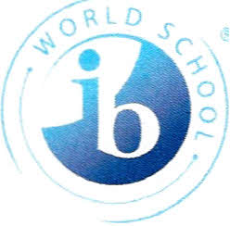

Mr. McClintock: mailto:mcclisc@boe.richmond.k12.ga.us
Mr. Guinn: guinnsc@boe.richmond.k12.ga.us

IB Diploma Programme Course Sequence
Class of 2021

Prep 9th Grade Curriculum
Hon. 9th Lit
Hon. Biology
Hon. Algebra I or Geometry
AP Human Geography
Hon. Span. I/II
PE/Health
1 Elective (CTAE Pathway)

10th Grade Curriculum
AP Language
Hon. Physics (optional Hon. Chem. w/8th Grade Physical Science)
Hon. Geometry or Hon. Algebra II
Hon. Span. II or IB Span. I
AP World History/Honors World History
Hon. Econ/Hon. Govt. (optional SAT/ACT Prep w/8th Grade Govt.)
1 Elective (AP Art History/Hon. Chemistry)
IB DP Curriculum: 11th and 12th Grade
All courses are two years except Math Studies
Group 1: Language A: Literature HL (2 years)
Group 2: Language B: Spanish B SL (2 Years)
Spanish ab initio SL

Group 3: History of the Americas HL (2 Years)

Group 4: Biology SL/HL (2Years)
OR Physics SL
Group 5: Mathematical Studies SL (1 Year)
Group 6: Visual Arts SL/HL; Psychology SL/HL
Music SL/HL
Environmental Systems and Societies SL

Theory of Knowledge (2 Years)

12th Grade Possible Options:
AP Calculus AB
AP Statistics
Dual-Enrollment

